MIS681—TA3: Automated Machine Learning

with AWS Sagemaker

Name: Snehal Mohan Kasture

Part 1: Please follow the demo in the class to (1) run the automated ML codes with AWS SageMaker, (2) run and discuss the codes for preprocessing.py, (3) discuss the codes for evaluation.py, (4) discuss the overall flow of the setting up the Automated ML pipeline. Please attach all the necessary screenshots. (5 points)
https://sagemaker-examples.readthedocs.io/en/latest/sagemaker-pipelines/tabular/abalone_build_train_deploy/sagemaker-pipelines-preprocess-train-evaluate-batch-transform.html
Ans:
SageMaker_Domain Setup->
This screenshot shows that my SageMaker domain was created successfully in the us-east-1 region. This was the first setup step because the domain allows me to launch SageMaker Studio and work inside the managed notebook environment.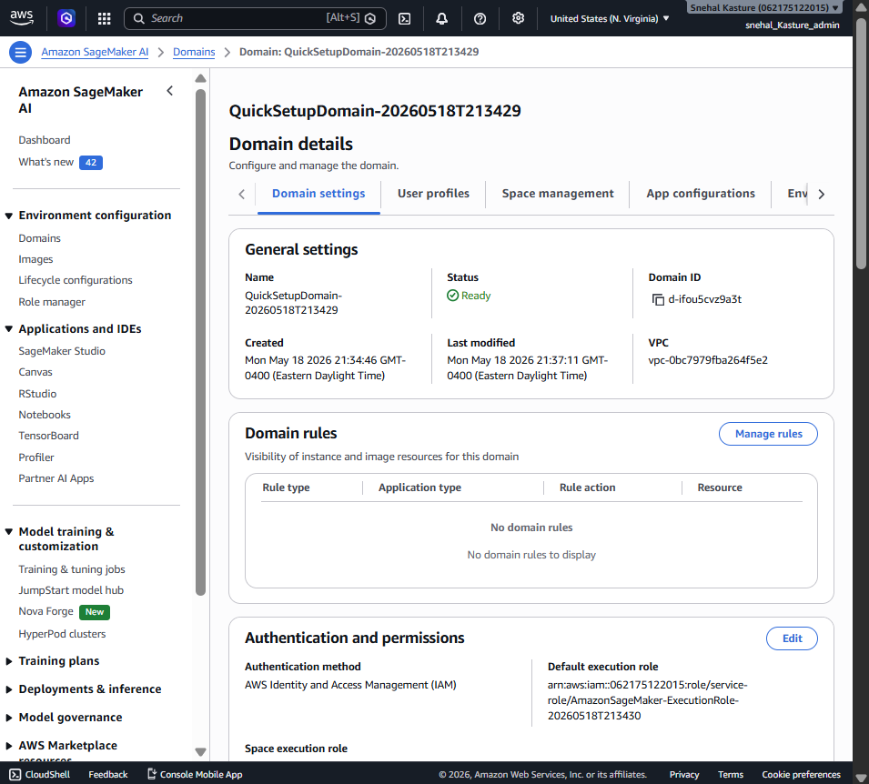

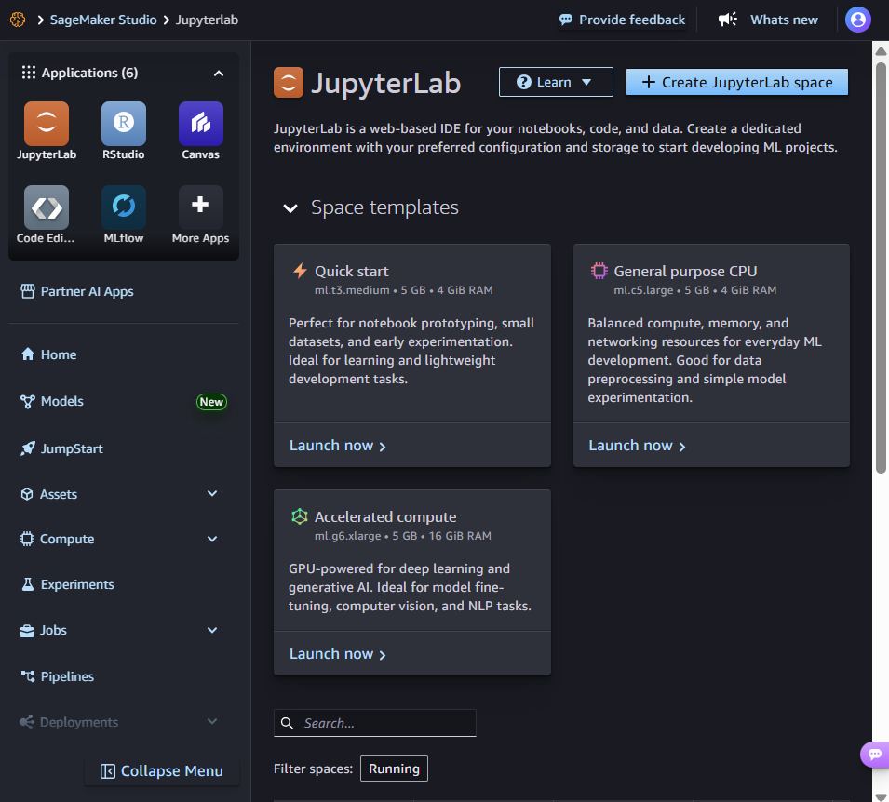
Installed SageMaker->
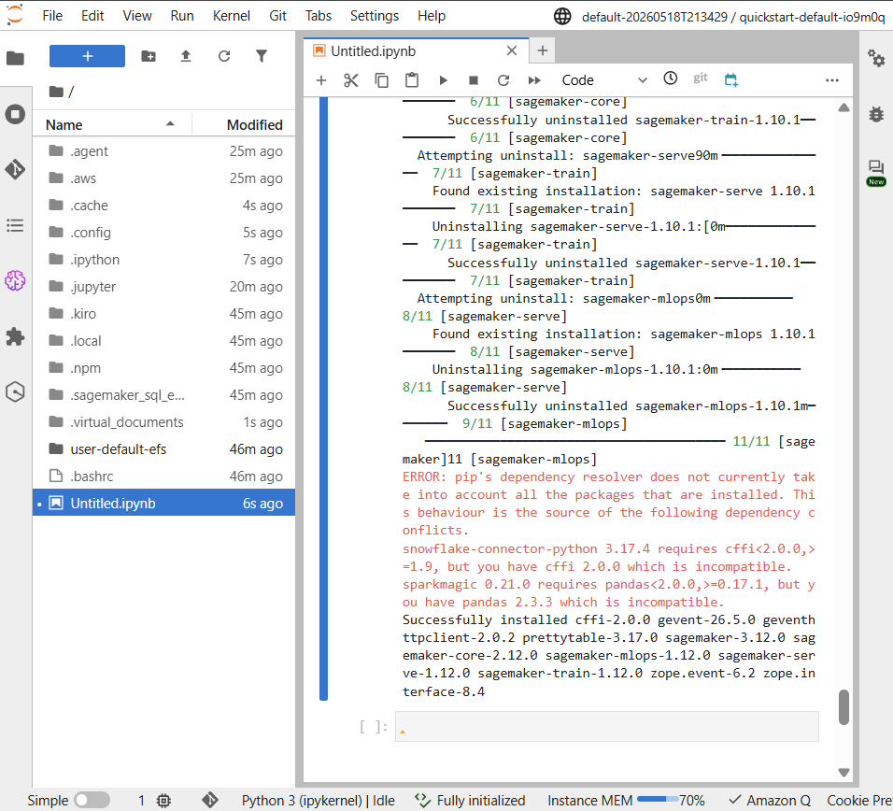

SageMaker SDK->
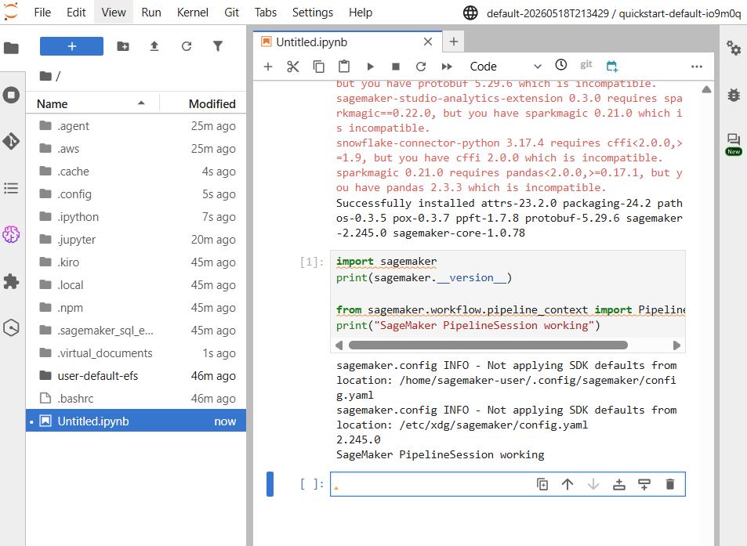
The SageMaker SDK was verified successfully after installation. This confirmed that the notebook environment was ready to define and execute SageMaker Pipeline steps.
Dataset Abalone successfully to S3->
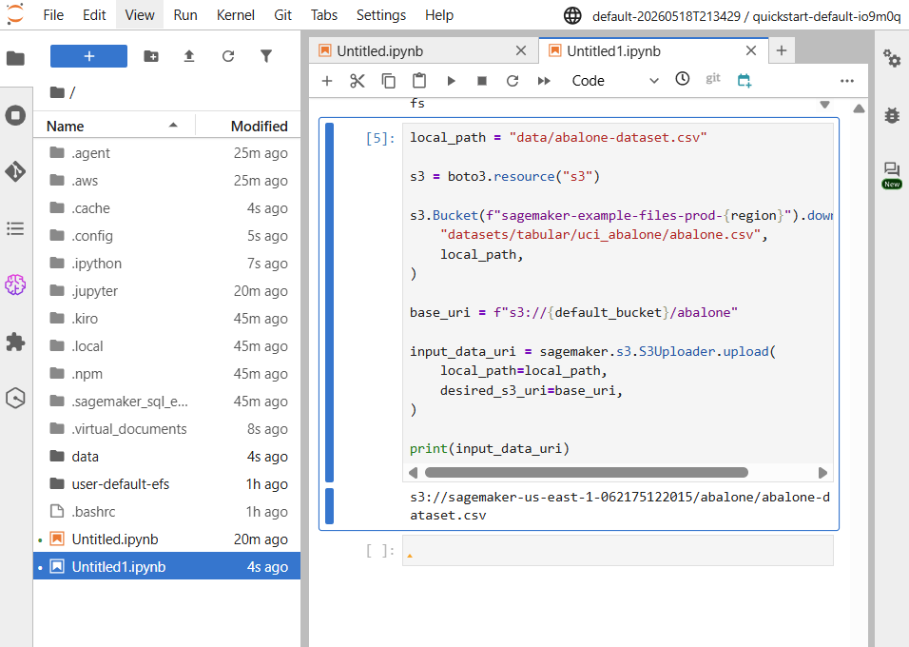

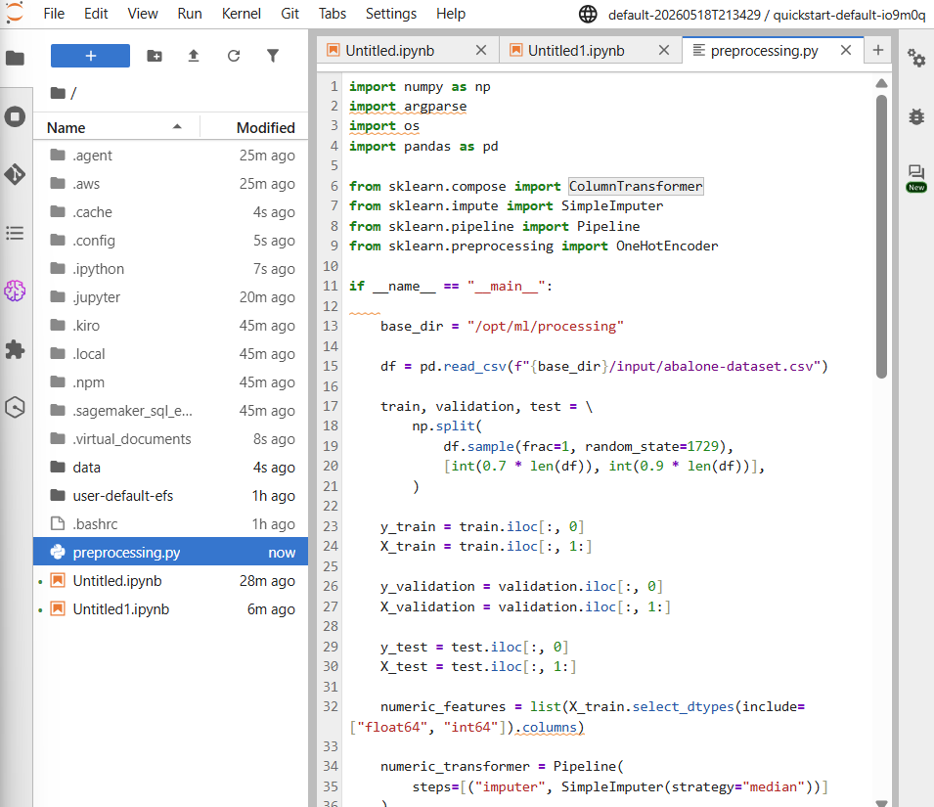
Processing->
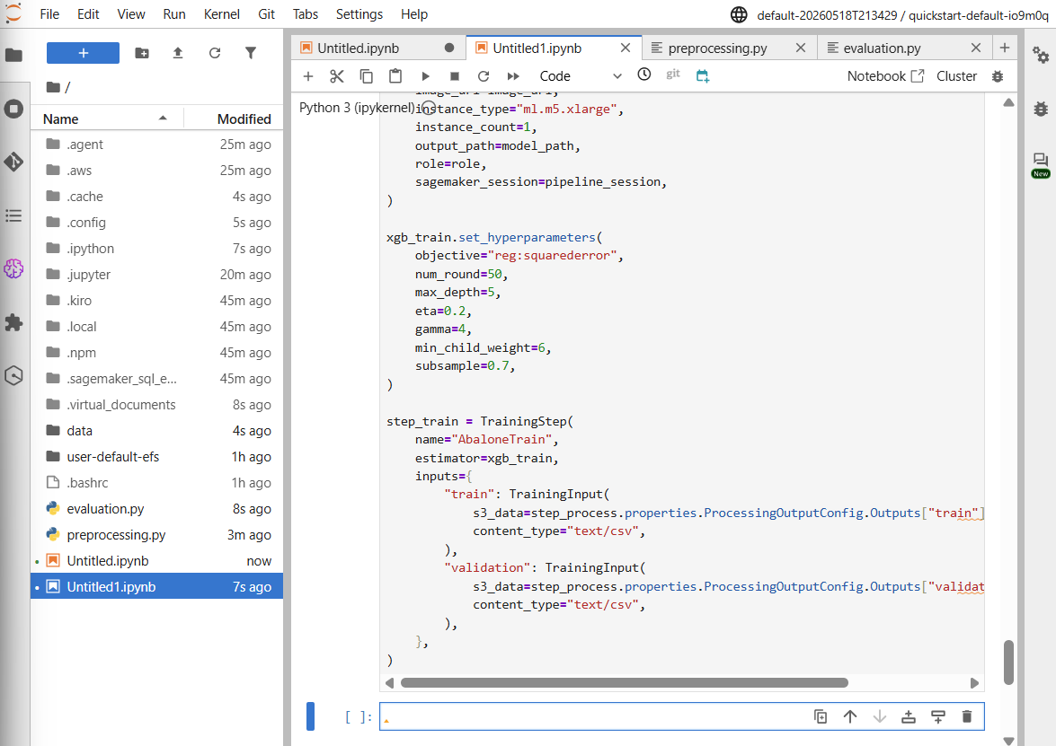

Pipeline created successfully /
AbalonePipelineMIS681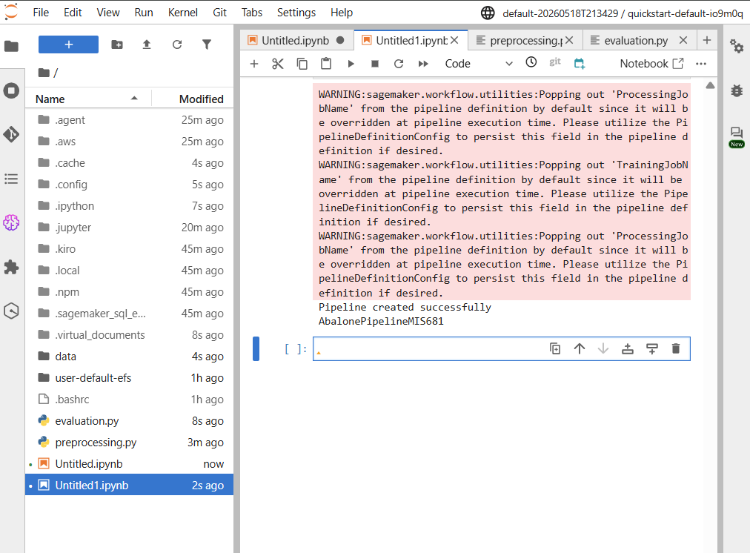
-Pipeline getting executed : execution = pipeline.start()
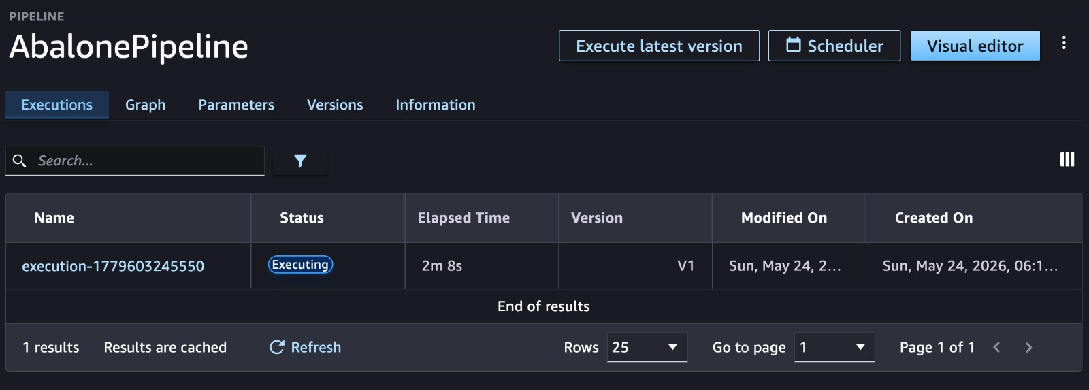
First block – preprocessing, Second block – Model training ->
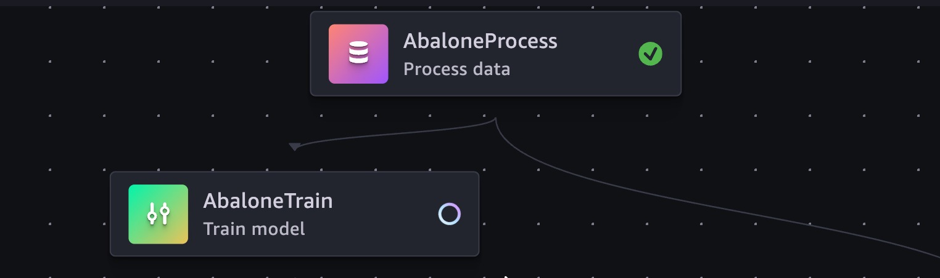

Model evolution ->


MSE condition when MSE less than 6
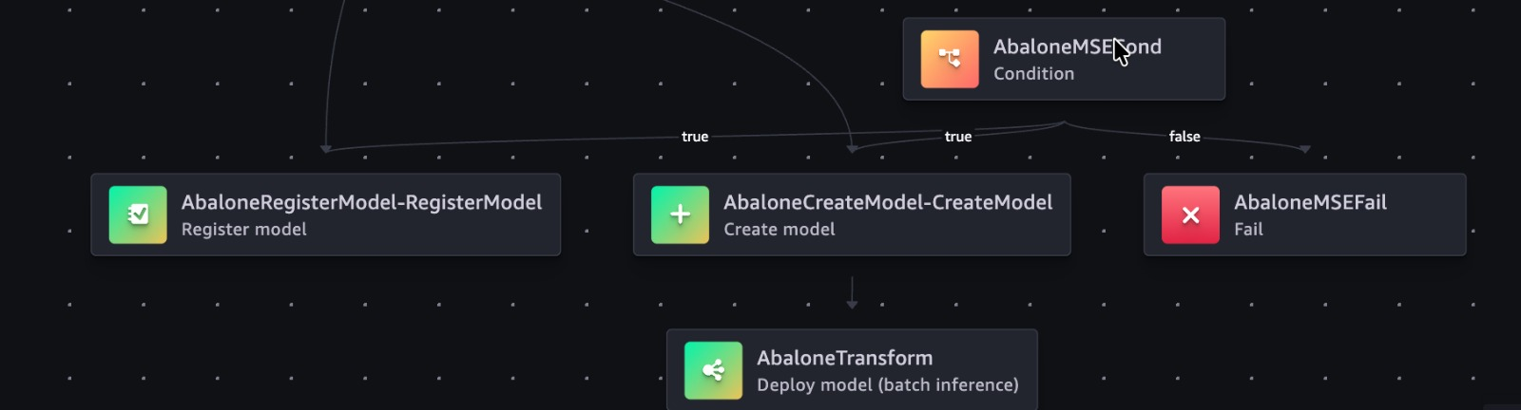

Pipeline parameters ->
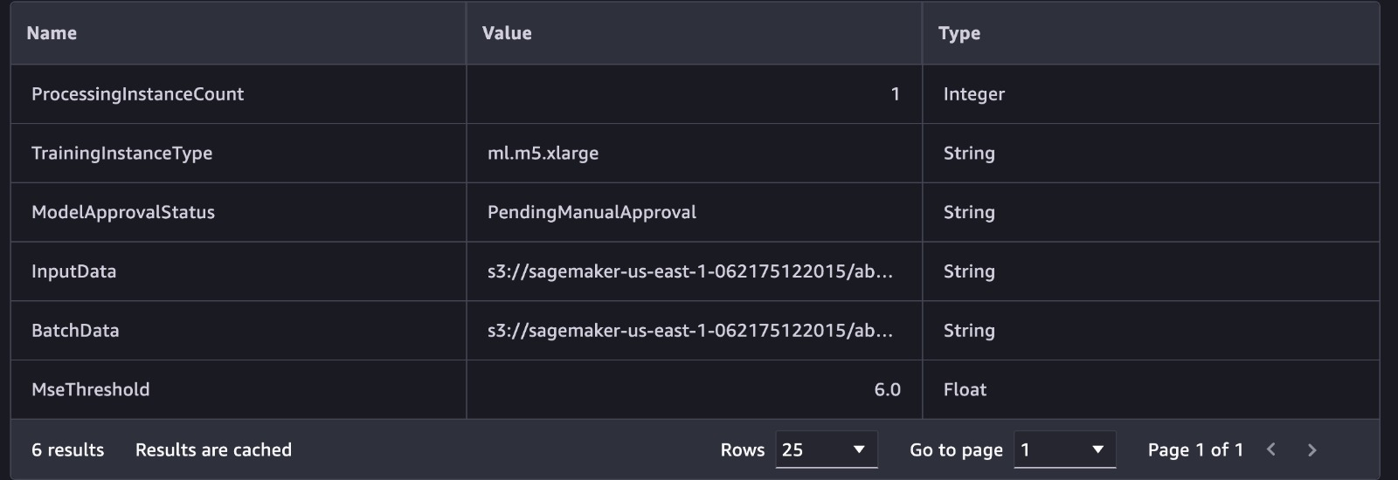

If we can see a green tick in front of the box, then that means that the stage is a success. Furthermore, if we double-click on the box which denotes the stage, we can see more details about that particular stage.
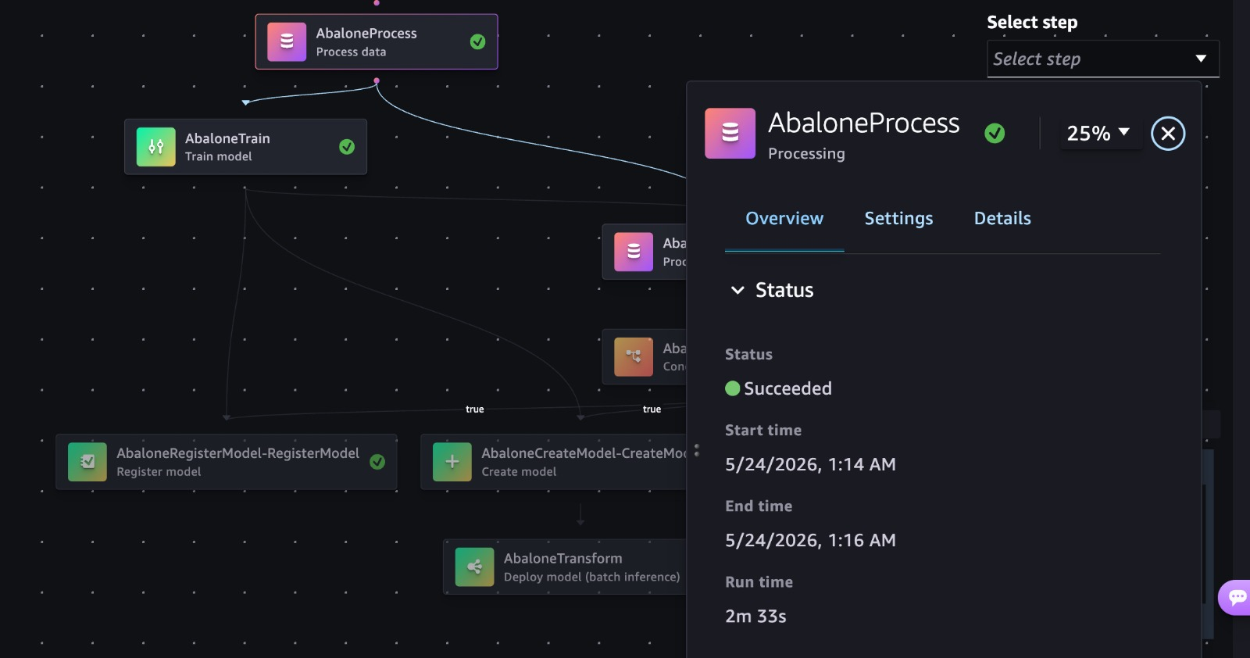

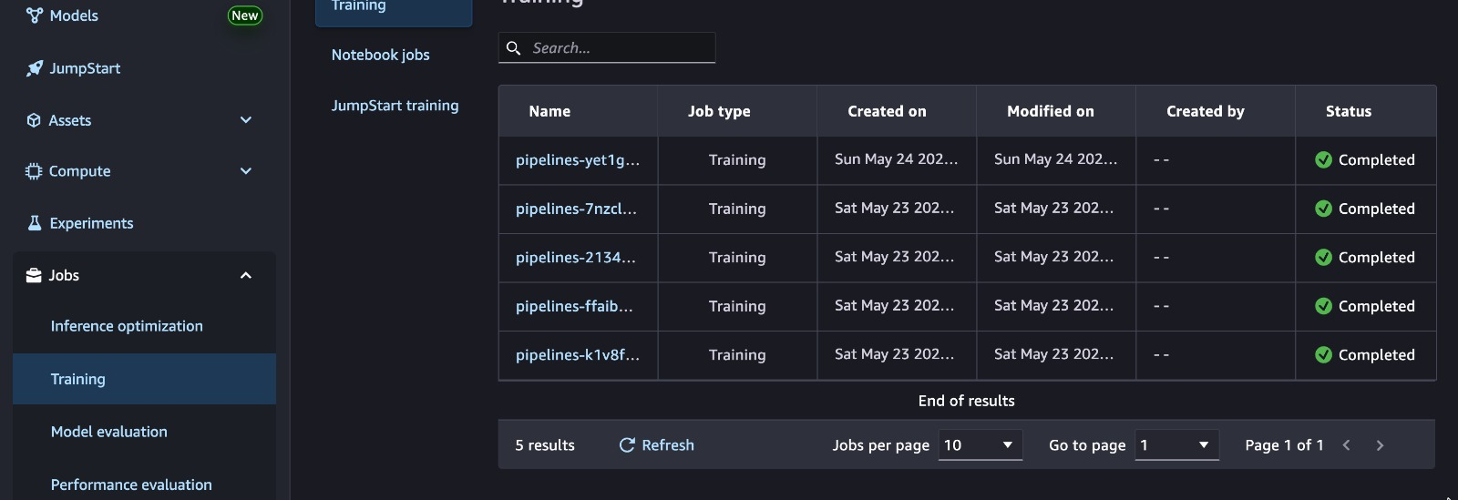

Part 2: Key Learning Reflections (2 points)
(Examples: learning from (1) the mistakes you made during the AutoML execution, (2) parameters and hyper parameters, (3) sagemaker studio features, (4) model enhancement experiments (e.g., changing the MSE threshold value and other hyperparameters such as eta, gamma, min_child_weight, subsample, etc.), (5) inferencing with the model deployment).
Ans:
1. SageMaker SDK and Environment Setup Issue
Challenge:
While starting the work in SageMaker Studio, the notebook was unable to import PipelineSession, and I received an error related to the SageMaker workflow module.
Root Cause:
The notebook environment was using an incompatible SageMaker SDK version, so some workflow and pipeline-related modules were missing.
What I Did:
  - Uninstalled the existing SageMaker packages
  - Installed a compatible SageMaker SDK version
  - Restarted the notebook kernel
  - Tested the imports again before continuing with the pipeline setup
- Key Takeaway:
This showed me that even if the pipeline code is correct, the workflow may still fail because of SDK version conflicts or environment setup issues. Before running any ML workflow, the notebook environment and package versions should always be verified properly.
2. Confusion Between Notebook Code and Pipeline Script Files
Challenge:
Initially, I was treating preprocessing.py and evaluation.py like regular notebook code, which made the pipeline structure confusing.
Root Cause:
I did not fully understand that these scripts are supposed to run inside SageMaker processing containers instead of directly inside the notebook environment.
What I Did:
  - Created a separate code/ folder for the scripts
  - Referenced the scripts properly from the pipeline definition
  - Verified that the preprocessing step generated train, validation, and test datasets correctly
- Key Takeaway:
After fixing this, the workflow structure became much clearer. The notebook acts more like the controller of the pipeline, while the actual preprocessing and evaluation logic runs separately inside SageMaker jobs. This also highlighted the importance of correct file paths and folder organization.
3. Understanding Hyperparameters, Evaluation, and Debugging
Challenge:
At first, XGBoost hyperparameters such as eta, gamma, max_depth, min_child_weight, subsample, and num_round looked like simple code settings without much practical meaning. I also faced debugging issues when some pipeline stages failed during execution.
Root Cause:
I had mostly seen these hyperparameters theoretically before, but not inside a real SageMaker training workflow. In addition, SageMaker notebook errors were sometimes too general, which made debugging difficult initially.
What I Did:
  - Observed how hyperparameters affected model training and evaluation
  - Used MSE to evaluate model performance
  - Checked pipeline execution stages step by step
  - Used CloudWatch logs to identify the actual cause of failed jobs
- Key Takeaway:
This gave me a better practical understanding of model tuning, overfitting, underfitting, and evaluation metrics. It also showed me that CloudWatch logs are extremely useful for debugging because they provide much more detailed information than notebook error messages alone.
4. Pipeline Execution and Debugging
Challenge:
During pipeline execution, some stages failed even though the previous step showed as completed successfully. One of the main issues happened during the evaluation stage, where the pipeline could not load the expected model artifact correctly.
Root Cause:
The issue was mainly related to incorrect file paths, missing outputs, and confusion between local notebook execution and SageMaker processing container execution. At first, it was difficult to identify the exact cause because the notebook only displayed a general pipeline error.
What I Did:
  - Checked the pipeline execution stages step by step
  - Verified preprocessing outputs and model artifact locations
  - Reviewed CloudWatch logs for detailed error messages
  - Fixed script paths and output references inside the pipeline workflow
  - Re-ran the pipeline after correcting the configuration issues
- Key Takeaway:
This gave me a much better understanding of how SageMaker Pipelines handle preprocessing, training, and evaluation as connected stages. It also showed me that debugging cloud-based ML workflows is very different from running local notebook code because each stage runs separately inside managed AWS environments.
Overall Reflection
- The assignment provided practical exposure to automated machine learning workflows in AWS.
- The environment setup, preprocessing logic, training pipeline, evaluation process, debugging steps, and cleanup activities were all important parts of the workflow.
- Troubleshooting the issues step by step made the SageMaker Pipeline architecture and execution flow much easier to understand in a real cloud environment.

Part 3: Please report your own Research and Learning beyond Class Discussions (2.5 points)
For example, we may explore the Amazon SageMaker Serverless Inference Deployment.
https://github.com/aws/amazon-sagemaker-examples/blob/main/serverless-inference/Serverless-Inference-Walkthrough.ipynb
You are free to choose ML related topics. You need to explore interested technologies in AWS to test your research findings.
Ans:
For my own research beyond the class discussion, I explored Amazon Textract, which is an AWS AI service used for extracting text, tables, and form data from scanned documents, PDFs, invoices, and images.
While working on machine learning workflows in AWS, I became interested in how businesses handle large amounts of document-based data. Many organizations still depend on manual data entry for invoices, receipts, application forms, insurance documents, and reports, which can take a lot of time and may also lead to human errors.
I found Amazon Textract interesting because it can automatically extract information from invoices, forms, and scanned documents instead of relying on manual data entry.
Unlike traditional OCR systems that mainly extract plain text, Textract can also understand the structure of forms and tables.

Amazon Textract
Amazon Textract is an AWS service used for extracting information from documents like structured and unstructured information from documents. It can identify:
- Printed text & Handwritten text
- Tables & Forms
- Key-value pairs
- Signatures
This makes it useful for automating document-heavy workflows.

Simple Workflow of Amazon Textract
Document Upload → Text Extraction → Table/Form Detection → Structured Output → Business Processing

Amazon Textract service dashboard in AWS Console:
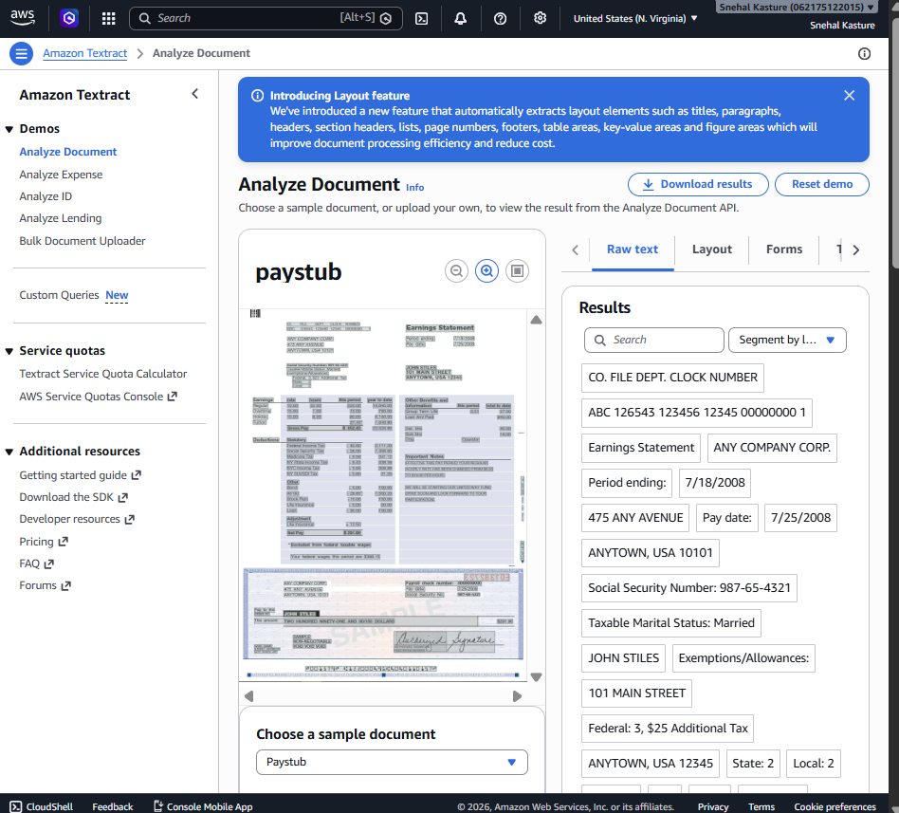

Insights
I selected this AI/ML service because it felt practical and closely connected to real business operations. During analytics and ERP-related work, many processes still involve invoices, purchase orders, forms, receipts, and scanned reports. Instead of manually typing information from these documents into systems, Amazon Textract can automate a large part of the process.

This topic also interested me because it shows how machine learning is used in day-to-day business automation, not only in prediction models.

Quick Comparison
Area | Traditional OCR | Amazon Textract
Text extraction | Basic text only | Text + document structure
Table recognition | Limited | Detects rows and columns
Form understanding | Weak | Detects key-value pairs
Handwritten text | Often inaccurate | Better support using ML
Manual effort | Higher | Reduced manual entry
Integration | Limited automation | Easy AWS integration

Technical Points
1. OCR + Machine Learning Combination
Traditional OCR mainly converts images into plain text. Amazon Textract goes further by using machine learning to understand document structure and relationships between fields.
Example:
- Invoice Number - Value
- Customer Name - Value
- Total Amount - Value
This makes the extracted data much more useful for automation.

2. Form and Table Detection
One feature I found interesting is the ability to detect tables and forms automatically. Textract can preserve table structure instead of returning only plain text.
For example:
- Invoice line items
- Bank statements
- Expense reports
- Employee forms
This can help businesses process documents more efficiently.

3. Confidence Scores
Textract also provides confidence scores for extracted fields. This helps identify whether the extracted information is reliable or whether manual review may still be required.
This is important because scanned documents can sometimes have:
- blurry text,
- tilted images,
- handwriting issues,
- or low-quality scans.

4. Integration with AWS Services
During my research, I also found that Textract can work together with other AWS services such as:
- Amazon S3 for document storage
- AWS Lambda for automation
- Amazon Comprehend for text analysis
- Amazon SageMaker for additional ML workflows
This makes it possible to build end-to-end intelligent document processing systems in AWS.

Example Business Use Cases
Industry | Example Use Case
Banking | Processing loan documents
Healthcare | Extracting patient form details
Insurance | Claims document processing
Retail | Invoice and receipt automation
HR | Resume and employee form processing
Finance | Expense and billing automation

Example Understanding Related to Workflow
A simple workflow could look like this:
Scanned Invoice → Amazon Textract → Extracted Fields → Validation → Database/System Update
Instead of manually entering data from invoices into a system, the information can be extracted automatically and processed further.

Advantages Observed
- Reduces manual data entry
- Faster document processing
- Better scalability for large document volumes
- Can handle both structured and semi-structured documents
- Integrates easily with other AWS services
Limitations list
- Accuracy can reduce for low-quality scans and Complex handwritten documents may still require manual review
- Confidence scores may vary depending on document clarity
- Cost can increase when processing very large numbers of documents

Main Takeaway
Before researching this topic, I mostly associated machine learning with prediction models and training workflows. Amazon Textract showed me another practical side of AI, where machine learning is used for document automation and operational efficiency.
Overall, this topic gave me a better understanding of how AWS AI services can support real-world business processes. It also showed how machine learning can be applied not only for analytics and prediction, but also for reducing manual work and improving business workflows.

Part 4: References (0.5)
(Examples: Links to AWS documentation, article references, etc.)
- AWS. Amazon SageMaker Pipelines Documentation.
https://docs.aws.amazon.com/sagemaker/latest/dg/pipelines.html
- Amazon SageMaker XGBoost Algorithm Documentation.
https://docs.aws.amazon.com/sagemaker/latest/dg/xgboost.html
- Amazon SageMaker Serverless Inference Documentation.
https://docs.aws.amazon.com/sagemaker/latest/dg/serverless-endpoints.html
- Amazon SageMaker Examples. SageMaker Pipelines: Preprocess, Train, Evaluate, and Batch Transform with Abalone Dataset.
https://sagemaker-examples.readthedocs.io/en/latest/sagemaker-pipelines/tabular/abalone_build_train_deploy/sagemaker-pipelines-preprocess-train-evaluate-batch-transform.html
- AWS Samples. Amazon SageMaker Examples: Serverless Inference Walkthrough.
https://github.com/aws/amazon-sagemaker-examples/blob/main/serverless-inference/Serverless-Inference-Walkthrough.ipynb
- Amazon SageMaker Pricing.
https://aws.amazon.com/sagemaker/pricing/
- XGBoost Developers. XGBoost Parameters Documentation.
https://xgboost.readthedocs.io/en/latest/parameter.html

